Budget Status — Local Verification
05 September 2026 · Round 1 · Not deployed. All financial figures in screenshots and sample reports are synthetic test data.
28/28 browser/render checks passed; 4/4 unit tests passed. Target-database compilation, live reporting and access checks are NOT RUN pending explicit deployment approval. This is local verification, not executive UAT acceptance.

Delivered behavior
Compact search arrangement with Presentation at the right; Show Summary unchecked by default; Print menu for PDF and PowerPoint using the report queue. Previous-period comparison was excluded as requested. PowerPoint uses slide images to preserve dashboard artwork; individual values are not editable shapes.
ID | Check | Result
FD-01 | PDF generated | PASS
FD-02 | PowerPoint includes all report pages | PASS
FD-03 | UI loads without JS errors | PASS
FD-04 | Show Summary starts unchecked | PASS
FD-05 | Unchecked suppresses ring summary | PASS
FD-06 | Checked enables ring summary | PASS
FD-07 | Unchecking immediately closes an open summary | PASS
FD-08 | Unchecked suppresses keyboard focus summary | PASS
FD-09 | Ring drill remains available | PASS
FD-10 | Other card summaries remain available | PASS
FD-11 | Compact presentation at far right | PASS
FD-12 | Presentation descriptions not clipped | PASS
FD-13 | PDF downloads with frozen period filename | PASS
FD-14 | PPTX downloads with frozen period filename | PASS
FD-15 | Export sends current filters and presentation | PASS
FD-16 | Print recovers after fail | PASS
FD-17 | Print recovers after status_fail | PASS
FD-18 | Print recovers after download_fail | PASS
FD-19 | Reset restores unchecked default | PASS
FD-20 | Search controls fit at 1024px | PASS
FD-21 | Search controls fit at 768px | PASS
FD-22 | Search controls fit at 390px | PASS
FD-23 | Arabic checkbox label | PASS
FD-24 | No JS errors through interaction | PASS
FD-25 | Print disabled after data-load failure | PASS
FD-26 | tiles report pages fit | PASS
FD-27 | rows report pages fit | PASS
FD-28 | map report pages fit | PASS
FD-UNIT-1 | Report scope, totals and all departments | PASS
FD-UNIT-2 | All presentations, Arabic and map boundary values | PASS
FD-UNIT-3 | Excluded balances remain separate from totals | PASS
FD-UNIT-4 | Department search scope and HTML escaping | PASS
FD-LIVE-1 | Compile report seed and ORDS bridge in target database | NOT RUN
FD-LIVE-2 | Live PDF/PPT totals reconcile with dashboard for each presentation | NOT RUN
FD-LIVE-3 | Live 401/403/404 and cross-user report ownership | NOT RUN

Search layout preview
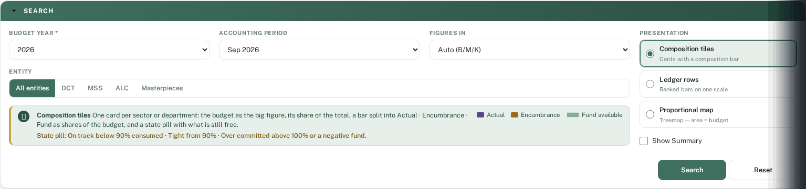

Evidence and review files
One numbered screenshot per browser/render case is in evidence_05-Sep-2026-01. That folder also contains sample PDF/PPTX output and three HTML presentation samples. The workbook links every case to its evidence. Deployment instructions: docs/budget-status-review.md.

